**Assignment 2 – documentation**

**Software design**

Pașca Eduard-Marian

Architecture

The frontend architecture is Single Page Application, meaning that the rendering is done in the browser by dynamically rewriting the page with new data instead of loading an entirely new page. My application consists of services, connecting the backend methods to the functions used by VueJS to display and transfer the content, components, such as various dialogs or certain elements that remain on the page at all times, and views which represent the rendered content when accessing the endpoints.

Routing

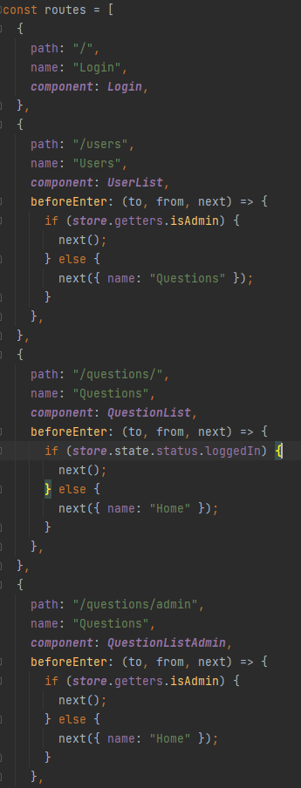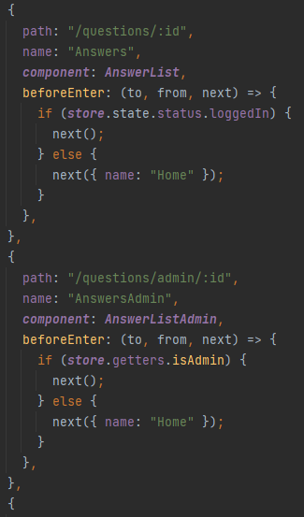The routing is pretty straightforward, having clear names for the endpoints, as it can be seen in the pictures below:

When logging in, based on the role, the user is redirected either to the Questions page, where they can see all the questions, or to the Users page, if they are an administrator. In the first case, they can add a new question and see all the questions asked on the forum. If they click on a question, the answers to that question will be displayed along the title, author and text of the question. In the case of an admin, they can perform CRUD on the users or press the Questions button which will redirect them to the Questions page. When clicking on a question here, they can perform moderating actions such as edit or delete, or they can see the answers to that question and moderate those.

The methods inside the views push a certain route from the router, based on the active method. For example, when clicking the questions button while logged as admin, the user will access the /questions/admin endpoint, and can go back to /users/ when they click the users button.

